Great Icosahedron

Definition
# Source: AI Source: Provided by: [Data Path: Persons Table -> ID Column: 1, Name_En Column: Motasem Essam] -> From: [ChatGPT] on [7/25/2026]
The Great Icosahedron is a regular, non-convex, star polyhedron belonging to the four classical Kepler–Poinsot polyhedra.
It is composed of 20 equilateral triangular faces, 30 edges, and 12 vertices. Five triangular faces meet at each vertex in a pentagrammic arrangement, producing a self-intersecting three-dimensional structure.
Its Schläfli symbol is:
$$\boxed{\{3,\frac{5}{2}\}}$$
Unlike a regular convex icosahedron, the Great Icosahedron contains intersecting faces and has a pentagram-shaped vertex figure.

Geometric Representation
# Source: AI Source: Provided by: [Data Path: Persons Table -> ID Column: 1, Name_En Column: Motasem Essam] -> From: [ChatGPT] on [7/25/2026]
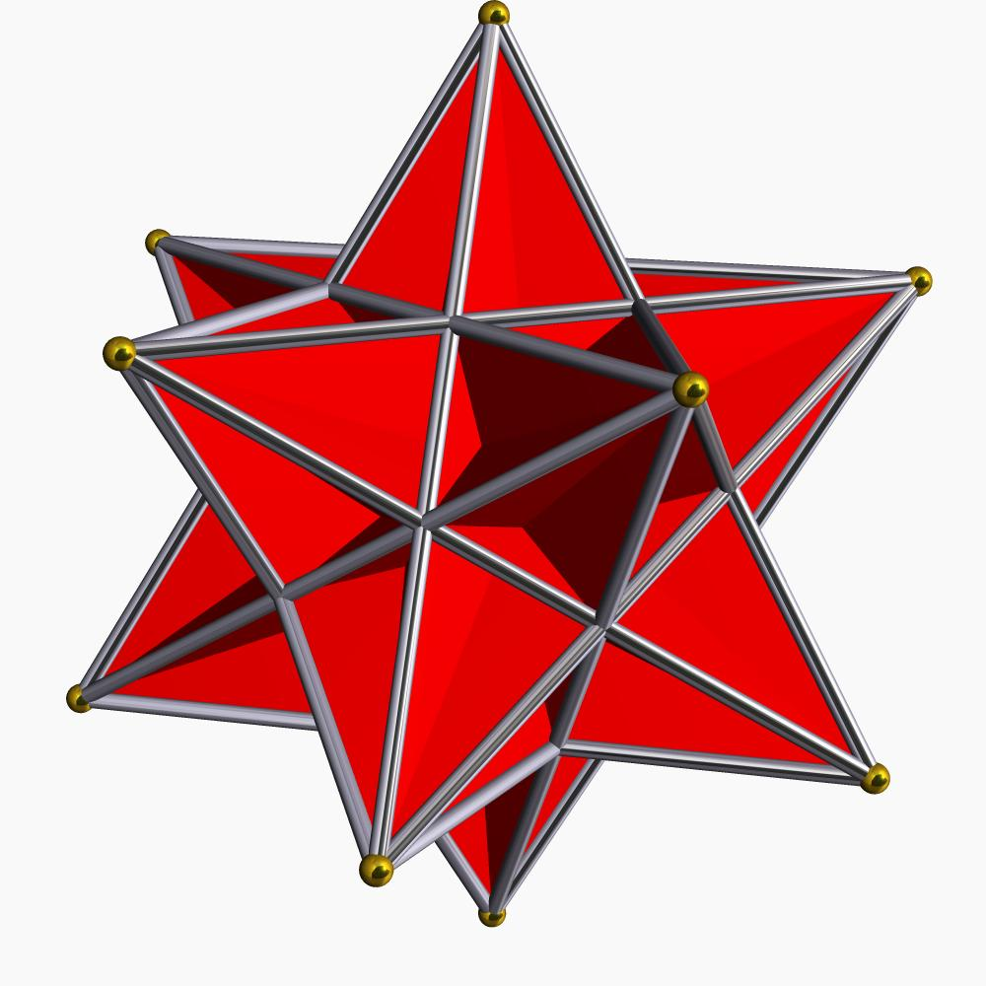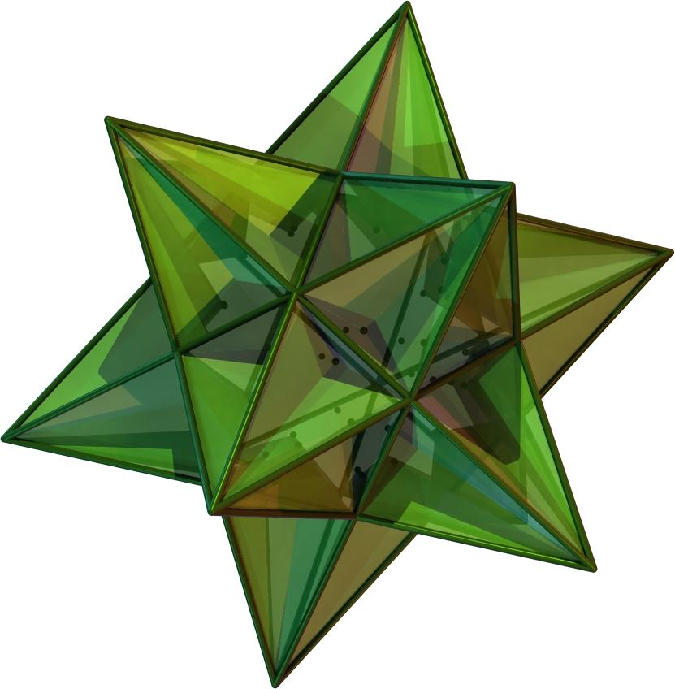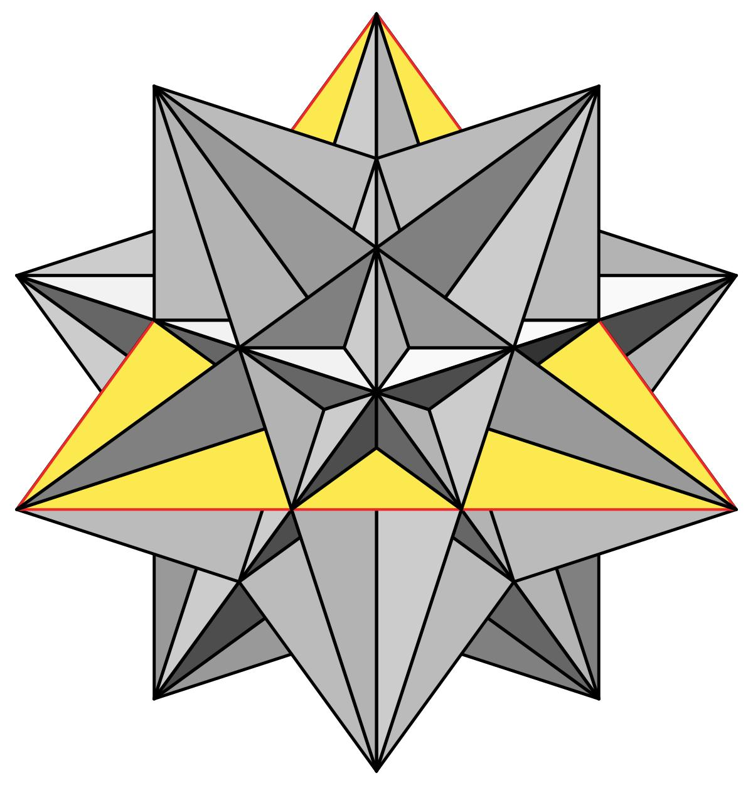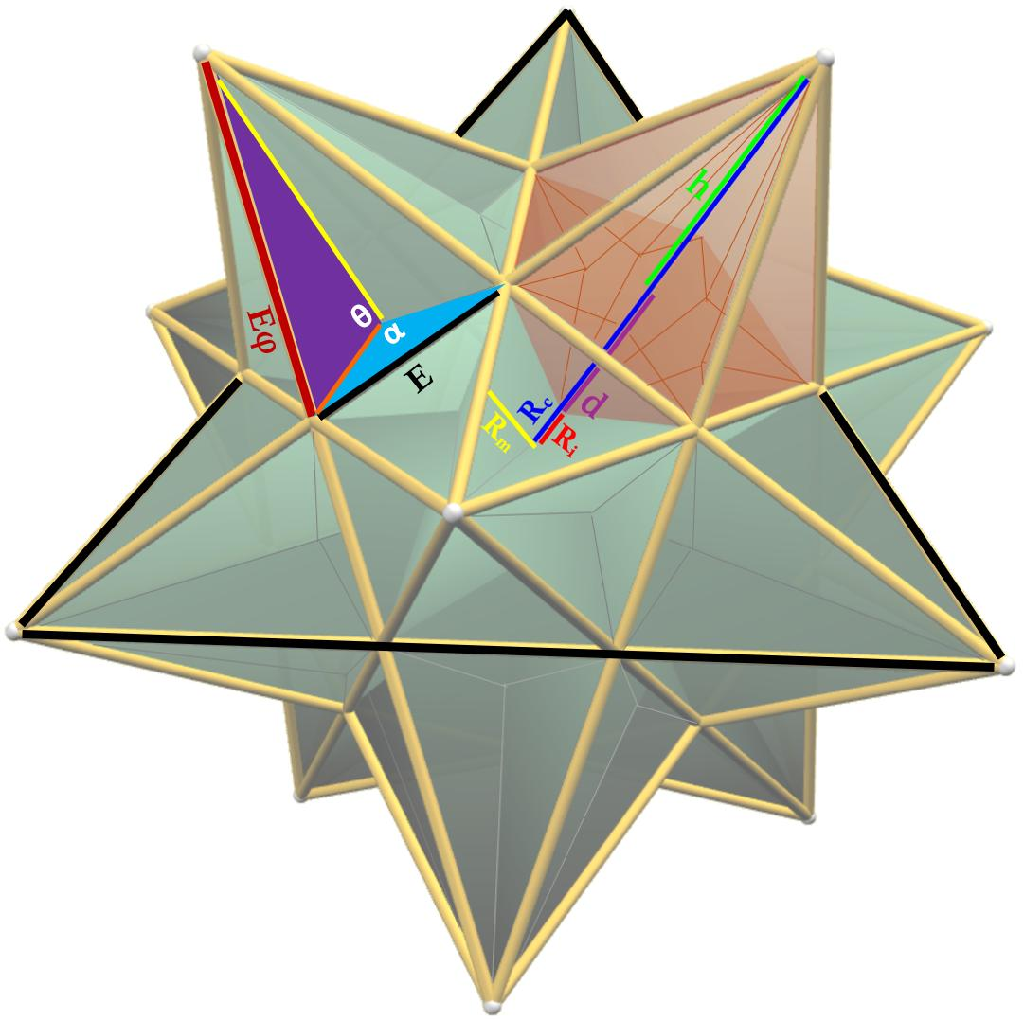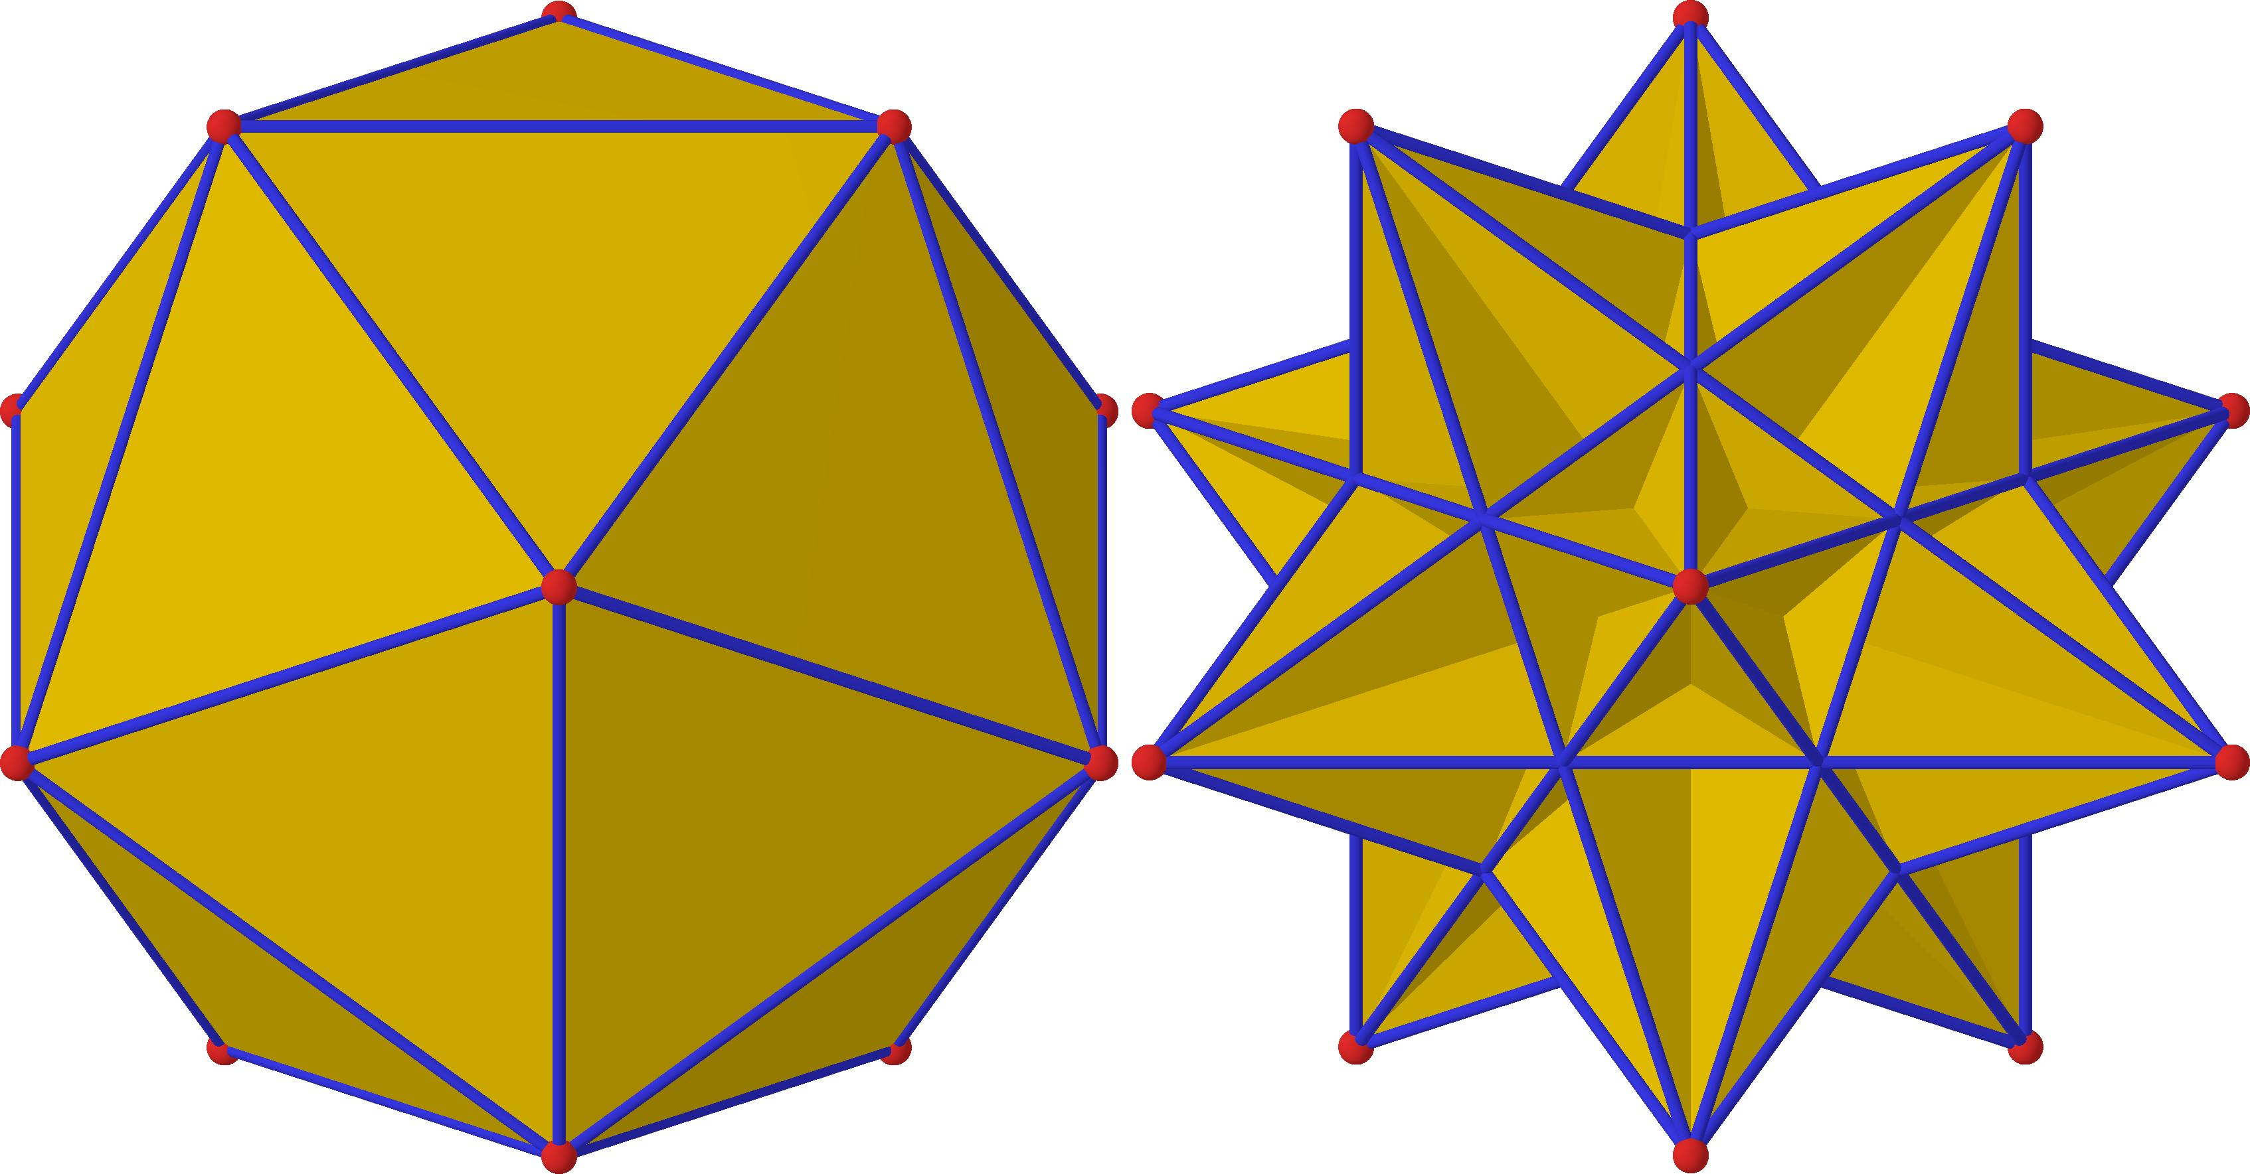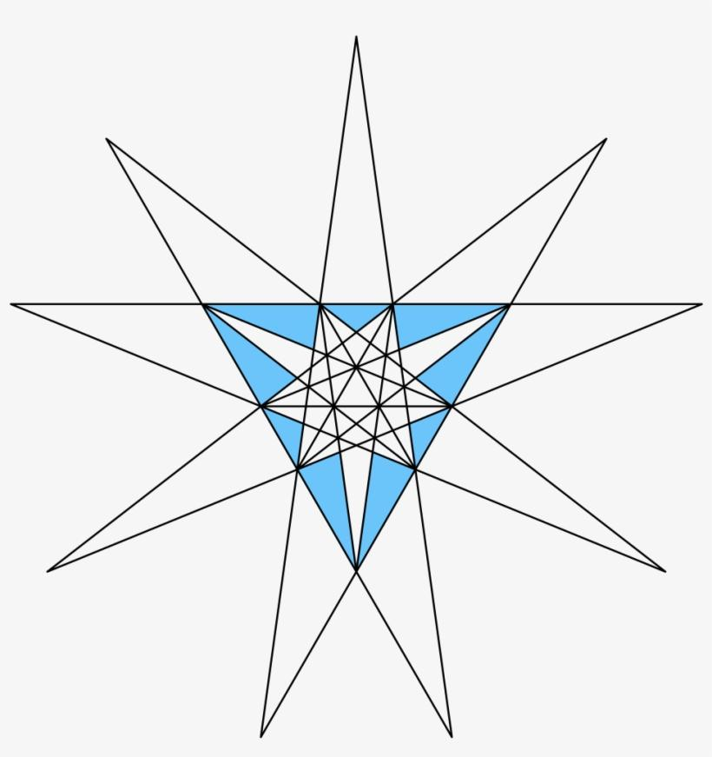

Geometric Structure
# Source: AI Source: Provided by: [Data Path: Persons Table -> ID Column: 1, Name_En Column: Motasem Essam] -> From: [ChatGPT] on [7/25/2026]
The Great Icosahedron consists of:
- 20 triangular faces: Each face is an equilateral triangle.
- 30 edges: Each edge belongs to two triangular faces.
- 12 vertices: Each vertex is shared by five triangular faces.
- Pentagrammic vertex arrangement: The five faces surrounding each vertex are arranged in a star-like configuration.
- Intersecting faces: Some triangular faces pass through other faces, creating a non-convex structure.
Its geometry is related to the regular icosahedron, but its edges and triangular faces are arranged differently.

Mathematical Properties
# Source: AI Source: Provided by: [Data Path: Persons Table -> ID Column: 1, Name_En Column: Motasem Essam] -> From: [ChatGPT] on [7/25/2026]
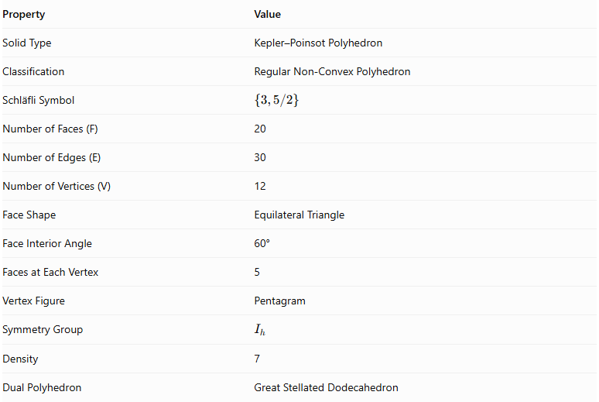
Property | Value
Solid Type | Kepler–Poinsot Polyhedron
Classification | Regular Non-Convex Polyhedron
Schläfli Symbol | $$\{3,5/2\}$$
Number of Faces (F) | 20
Number of Edges (E) | 30
Number of Vertices (V) | 12
Face Shape | Equilateral Triangle
Face Interior Angle | 60°
Faces at Each Vertex | 5
Vertex Figure | Pentagram
Symmetry Group | $$I_{h}$$
Density | 7
Dual Polyhedron | Great Stellated Dodecahedron

Face Composition
# Source: AI Source: Provided by: [Data Path: Persons Table -> ID Column: 1, Name_En Column: Motasem Essam] -> From: [ChatGPT] on [7/25/2026]
The Great Icosahedron has 20 congruent equilateral triangular faces.
Each face has:
- Three equal sides.
- Three equal interior angles of ${60}^{∘}$.
- A regular triangular shape.
- Intersections with other triangular faces.
The total number of faces is:
$$F=20$$
The faces are ordinary equilateral triangles rather than pentagrams. Its star-like appearance comes from the arrangement of the faces around its vertices.

Vertex Configuration
# Source: AI Source: Provided by: [Data Path: Persons Table -> ID Column: 1, Name_En Column: Motasem Essam] -> From: [ChatGPT] on [7/25/2026]
Five triangular faces meet at every vertex in a pentagrammic arrangement.
Its vertex figure is a pentagram, represented by:
$$\{\frac{5}{2}\}$$
The vertex configuration is:
$$\boxed{\frac{(3^{5})}{2}}$$
This notation describes five triangular faces arranged around each vertex in a star-like sequence.

Construction
# Source: AI Source: Provided by: [Data Path: Persons Table -> ID Column: 1, Name_En Column: Motasem Essam] -> From: [ChatGPT] on [7/25/2026]
The Great Icosahedron can be constructed using the vertices of a regular icosahedron.
- Begin with a regular icosahedron containing 12 vertices.
- Consider the five nearest neighboring vertices connected to a selected vertex.
- Identify the five next-nearest neighboring vertices.
- Connect appropriate combinations of these vertices to form equilateral triangles.
- Extend the triangular face arrangement to produce the complete regular star polyhedron.
- Repeat the arrangement symmetrically to obtain 20 triangular faces.
The resulting Great Icosahedron retains the 12 vertices of the original icosahedron, but its edges and faces form a different structure.

Geometric Dimensions and Formulas
# Source: AI Source: Provided by: [Data Path: Persons Table -> ID Column: 1, Name_En Column: Motasem Essam] -> From: [ChatGPT] on [7/25/2026]
Let:
- $a$ = edge length of the Great Icosahedron.
- $A_{f}$ = area of one triangular face.
- $S$ = sum of the individual triangular face areas.
Area of one equilateral triangular face:
$$A_{f}=\frac{\sqrt{3}}{4}a^{2}$$
Sum of the areas of all 20 faces:
$$S=20A_{f}$$
$$\boxed{S=5\sqrt{3}a^{2}}$$
This is the sum of the individual face areas, not necessarily the area of the exposed external boundary, because the faces intersect.
Number of edges:
$$E=30$$
Number of vertices:
$$V=12$$
A conventional single volume formula should be specified with a particular interpretation of the self-intersecting solid and its density.

Euler Characteristic
# Source: AI Source: Provided by: [Data Path: Persons Table -> ID Column: 1, Name_En Column: Motasem Essam] -> From: [ChatGPT] on [7/25/2026]
For the conventional polyhedron counts:
$$chi=V-E+F$$
Substituting:
$$chi=12-30+20$$
$$\boxed{chi=2}$$
The Great Icosahedron satisfies the conventional Euler characteristic of 2.

Density
# Source: AI Source: Provided by: [Data Path: Persons Table -> ID Column: 1, Name_En Column: Motasem Essam] -> From: [ChatGPT] on [7/25/2026]
The density of the Great Icosahedron is:
$$\boxed{D=7}$$
Density describes the number of times the polyhedron winds around or covers a generic point when its intersecting faces are taken into account.
It has the same density as its dual, the Great Stellated Dodecahedron.

Constructing a Great Icosahedron

Geometric Instruments
# Source: AI Source: Provided by: [Data Path: Persons Table -> ID Column: 1, Name_En Column: Motasem Essam] -> From: [ChatGPT] on [7/25/2026]
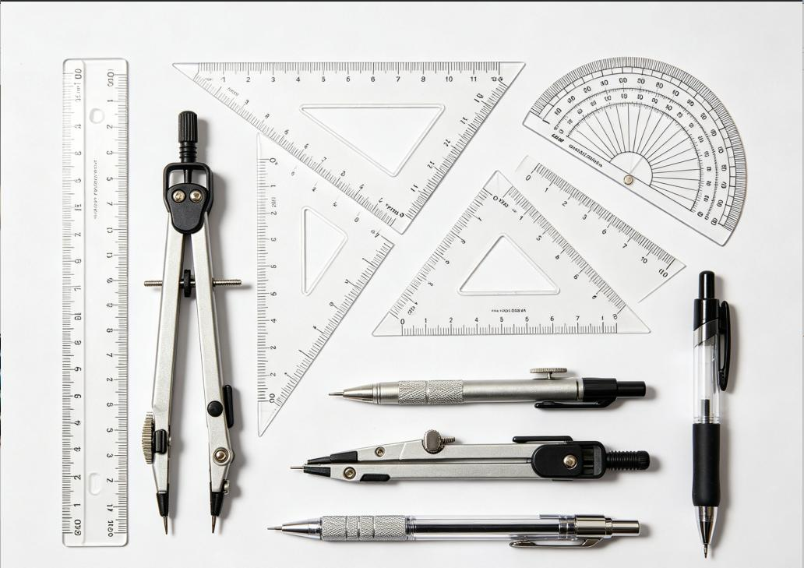
- Ruler / Straightedge: Drawing triangular faces, dodecahedral edges, and construction lines.
- Compass: Constructing equilateral triangles, regular pentagons, and transferring lengths.
- Protractor: Checking triangle angles and construction inclinations.
- Set Squares: Drawing perpendicular and parallel construction lines.
- Pencil: Drawing outlines, diagonals, and construction marks.
- Eraser: Removing unnecessary construction lines.
- Cardboard or Construction Paper: Preparing the triangular and pentagrammic components.
- Scissors and Adhesive: Cutting and assembling the physical model.

Instrument-Based Construction Procedures

Method 1: Construction Using a Regular Icosahedron Framework
# Source: AI Source: Provided by: [Data Path: Persons Table -> ID Column: 1, Name_En Column: Motasem Essam] -> From: [ChatGPT] on [7/25/2026]
- Construct a regular icosahedron with 20 equilateral triangular faces.
- Identify its 12 vertices and 30 edges.
- At each vertex, identify the five next-nearest vertices, excluding the five directly connected neighboring vertices.
- Use the compass to compare the distances between candidate vertices.
- Select groups of three vertices whose pairwise distances are equal to the golden ratio $φ$ times the original icosahedron edge length.
- Connect each selected group of three vertices to form an equilateral triangle.
- Repeat the selection symmetrically until all 20 triangular faces have been constructed.
- Check that five triangular faces meet at each of the 12 true vertices in a pentagrammic arrangement.
- Distinguish the true edges from the internal intersections of the extended faces.
- Complete the drawing by showing the visible and hidden portions of the polyhedron.
This method uses the 20 equilateral triangles formed by groups of vertices at the specified golden-ratio distance.

Method 2: Construction Using a Squashed Dodecahedron and Pentagrammic Pyramids
# Source: AI Source: Provided by: [Data Path: Persons Table -> ID Column: 1, Name_En Column: Motasem Essam] -> From: [ChatGPT] on [7/25/2026]
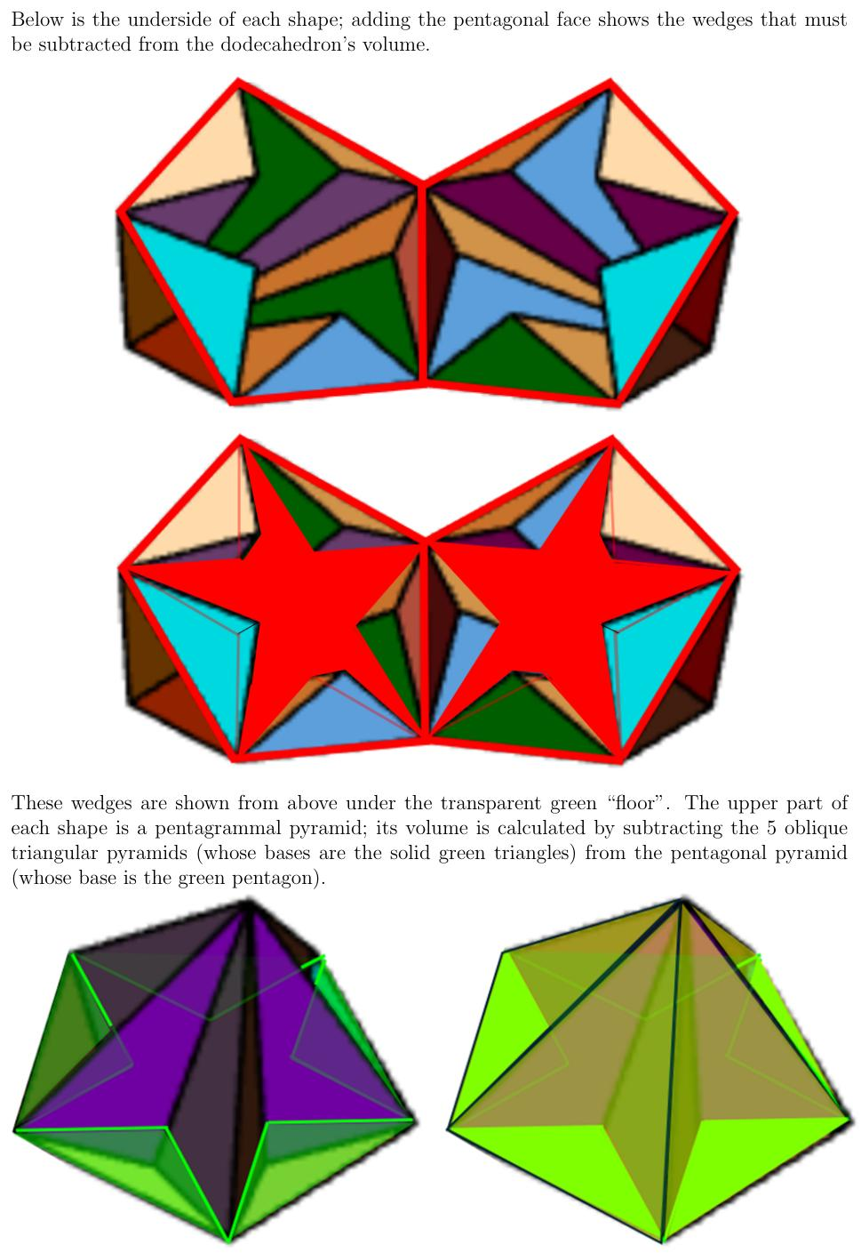
- Construct the net of a regular dodecahedron using 12 regular pentagons.
- Modify the proportions of the dodecahedral framework to form the required flattened or squashed dodecahedral core.
- Assemble the core while preserving its 12 pentagonal face positions.
- Construct a pentagrammic pyramid net for each of the 12 pentagonal faces.
- Determine the required pyramid height using the dodecahedral edge length.
- Fold and assemble the 12 pentagrammic pyramids.
- Attach each pyramid to the corresponding pentagonal face position of the core.
- Arrange the pyramids so their triangular regions form the 20 equilateral faces of the great icosahedron.
- Check the alignment of the intersecting triangular faces and their pentagrammic vertex arrangements.
- Complete the model by removing or concealing unnecessary internal construction supports.
This construction follows the model-building method described by Cundy and Rollett and presented in Wolfram MathWorld.

Method 3: Construction Using a Paper Model
# Source: AI Source: Provided by: [Data Path: Persons Table -> ID Column: 1, Name_En Column: Motasem Essam] -> From: [ChatGPT] on [7/25/2026]
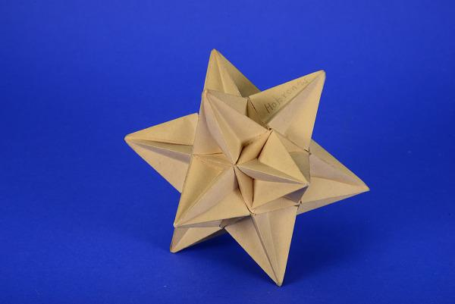
- Draw the required pentagonal and triangular construction patterns.
- Prepare the net for the squashed dodecahedral core.
- Construct the 12 pentagrammic pyramid nets.
- Divide the triangular regions into suitable panels for paper assembly.
- Add attachment tabs where necessary.
- Cut out the components using scissors.
- Fold the panels along their designated fold lines.
- Assemble the core and attach the pentagrammic pyramids.
- Join the components while preserving the intersecting face arrangement.
- Check that the completed model has 20 equilateral triangular faces, 30 edges, and 12 true vertices.
A detailed paper sculpture model described by Wolfram MathWorld uses 180 individual pieces.

Relationship to Other Geometric Solids
# Source: AI Source: Provided by: [Data Path: Persons Table -> ID Column: 1, Name_En Column: Motasem Essam] -> From: [ChatGPT] on [7/25/2026]
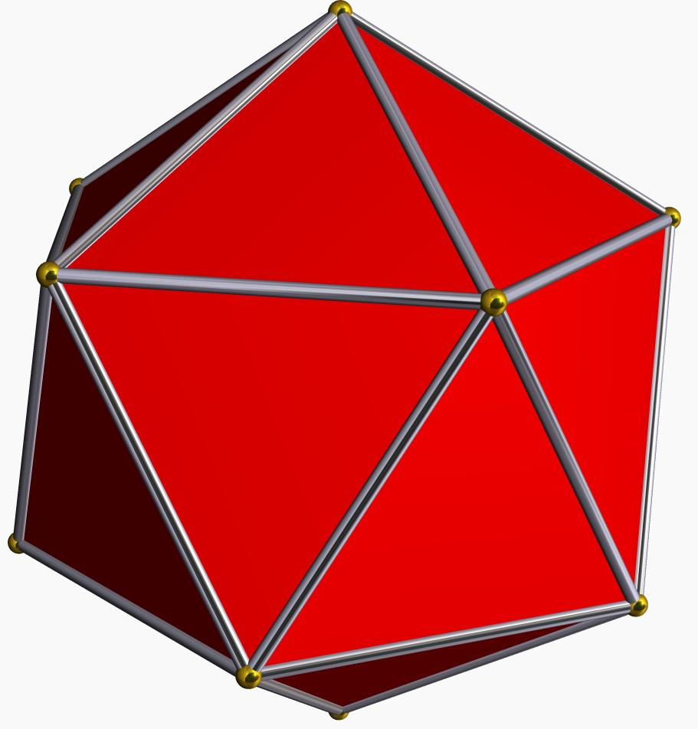
Regular Icosahedron
The convex Platonic solid that shares the same 12 vertex positions. The Great Icosahedron has a different edge and face arrangement.
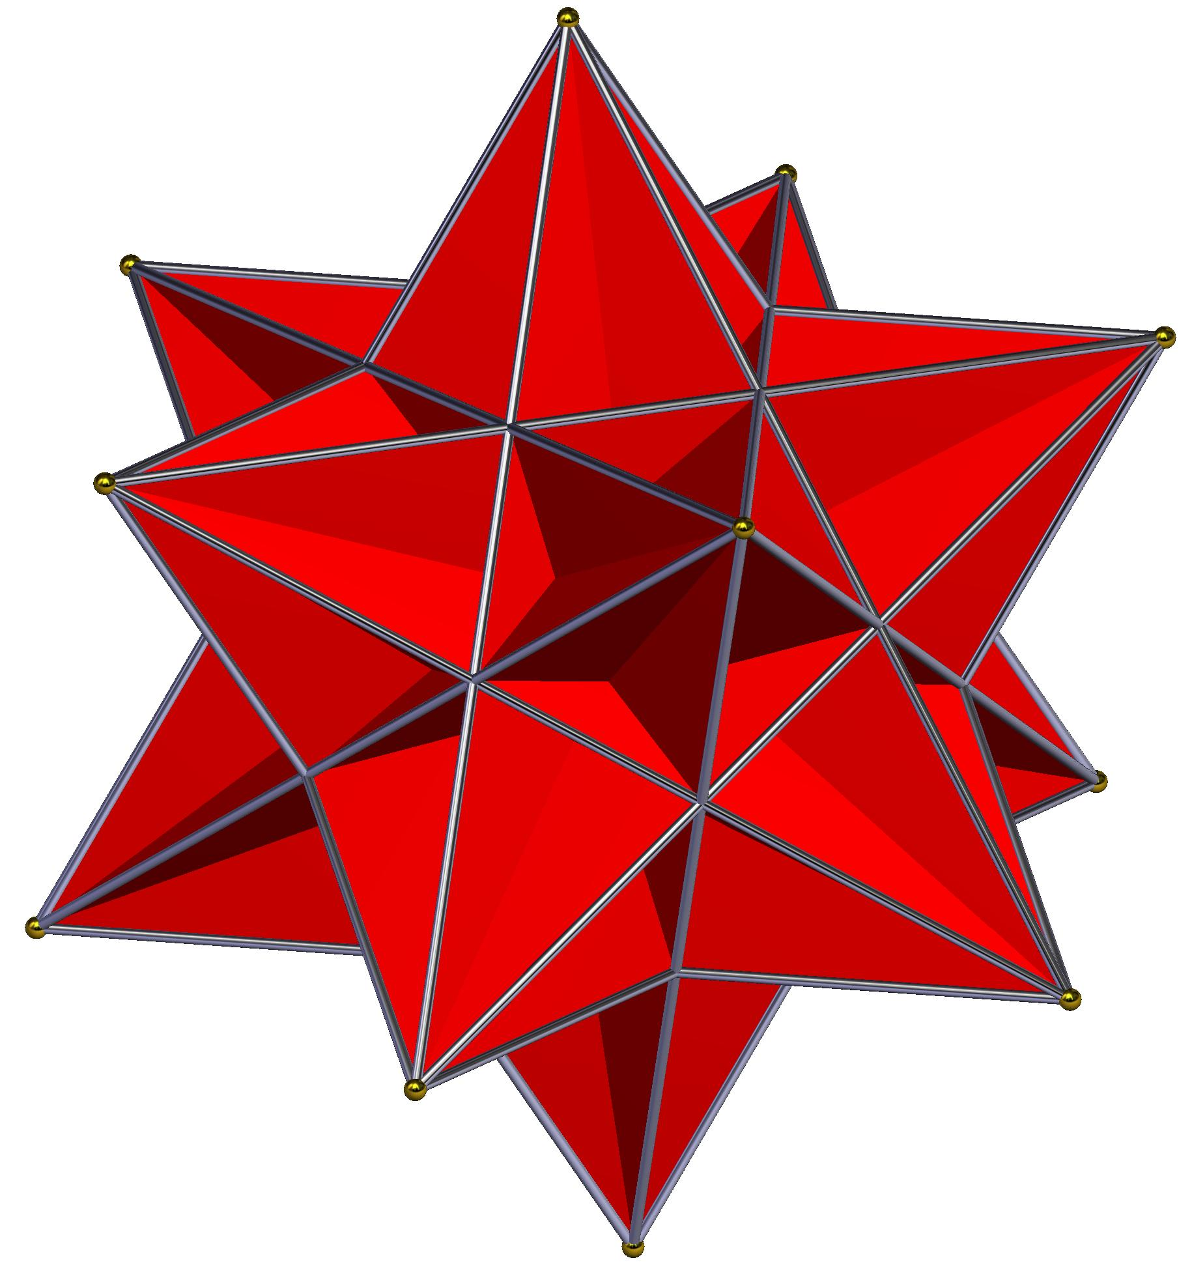
Great Stellated Dodecahedron
The dual polyhedron of the Great Icosahedron. Its 12 pentagrammic faces correspond to the 12 vertices of the Great Icosahedron.
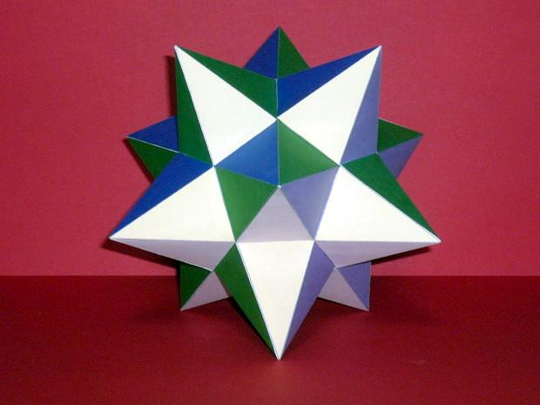
Small Stellated Dodecahedron
Another Kepler–Poinsot polyhedron, composed of 12 pentagrammic faces.
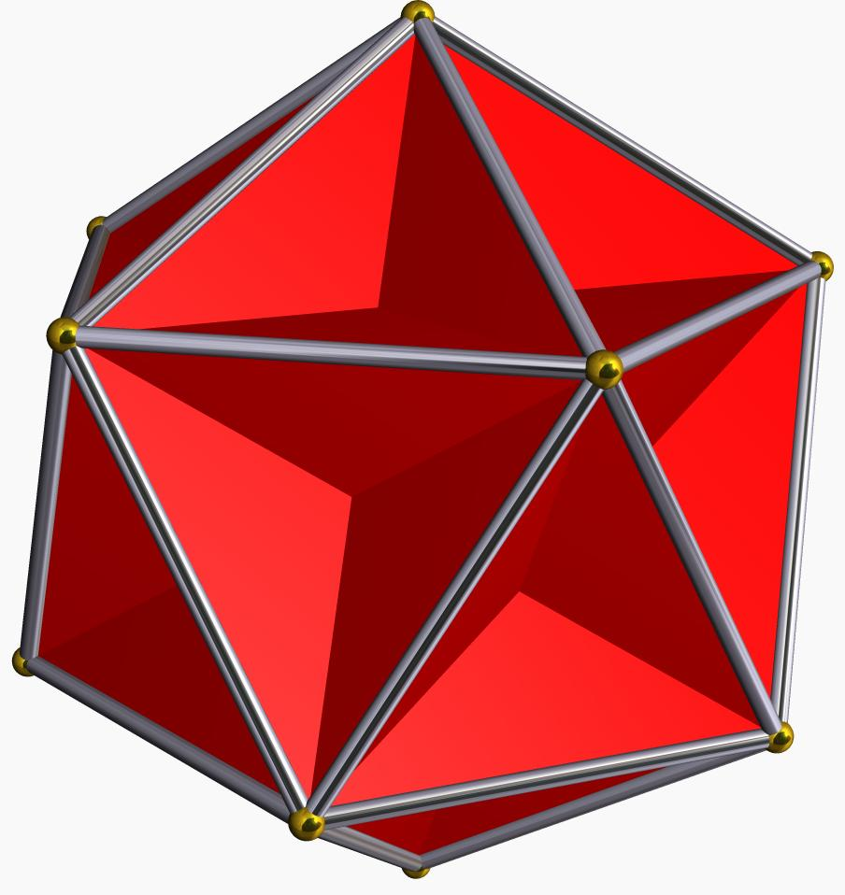
Great Dodecahedron
A regular star polyhedron with 12 pentagonal faces and pentagrammic vertex figures.

Comparison with Other Kepler–Poinsot Polyhedra
# Source: AI Source: Provided by: [Data Path: Persons Table -> ID Column: 1, Name_En Column: Motasem Essam] -> From: [ChatGPT] on [7/25/2026]
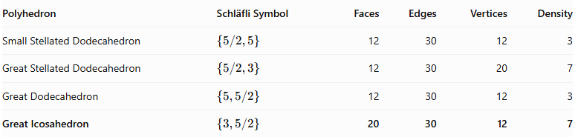
Polyhedron | Schläfli Symbol | Faces | Edges | Vertices | Density
Small Stellated Dodecahedron | $$\{5/2,5\}$$ | 12 | 30 | 12 | 3
Great Stellated Dodecahedron | $$\{5/2,3\}$$ | 12 | 30 | 20 | 7
Great Dodecahedron | $$\{5,5/2\}$$ | 12 | 30 | 12 | 3
Great Icosahedron | $$\{3,5/2\}$$ | 20 | 30 | 12 | 7

Historical Background
# Source: AI Source: Provided by: [Data Path: Persons Table -> ID Column: 1, Name_En Column: Motasem Essam] -> From: [ChatGPT] on [7/25/2026]
- 1619 – Johannes Kepler: Published his studies of regular star polyhedra, including the Small Stellated Dodecahedron and Great Stellated Dodecahedron.
- 1809 – Louis Poinsot: Rediscovered and described the Great Icosahedron and Great Dodecahedron.
- 1859 – Arthur Cayley: Used the name Kepler–Poinsot polyhedra for these four regular star polyhedra.
- 1813 – Augustin-Louis Cauchy: Established that these four exhaust the possibilities for regular star polyhedra in three-dimensional space.

Main Classification
# Source: AI Source: Provided by: [Data Path: Persons Table -> ID Column: 1, Name_En Column: Motasem Essam] -> From: [ChatGPT] on [7/25/2026]
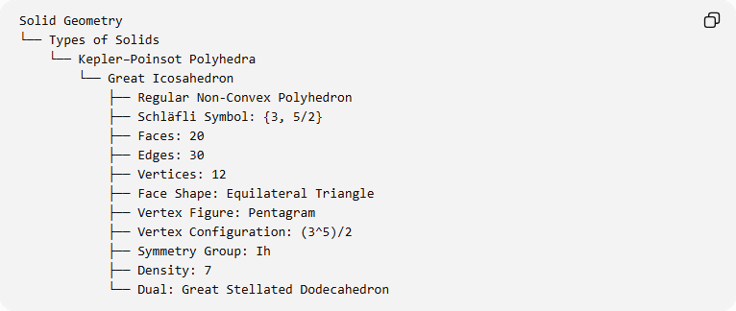
Solid Geometry
└── Types of Solids
└── Kepler–Poinsot Polyhedra
└── Great Icosahedron
├── Regular Non-Convex Polyhedron
├── Schläfli Symbol: {3, 5/2}
├── Faces: 20
├── Edges: 30
├── Vertices: 12
├── Face Shape: Equilateral Triangle
├── Vertex Figure: Pentagram
├── Vertex Configuration: (3^5)/2
├── Symmetry Group: Ih
├── Density: 7
└── Dual: Great Stellated Dodecahedron

Key Points
# Source: AI Source: Provided by: [Data Path: Persons Table -> ID Column: 1, Name_En Column: Motasem Essam] -> From: [ChatGPT] on [7/25/2026]
- The Great Icosahedron is one of the four Kepler–Poinsot polyhedra.
- It is a regular non-convex star polyhedron.
- It has 20 equilateral triangular faces.
- It contains 30 edges and 12 vertices.
- Five triangular faces meet at each vertex.
- Its vertex figure is a pentagram.
- Its Schläfli symbol is $\{3,5/2\}$.
- Its density is 7.
- Its dual is the Great Stellated Dodecahedron.
- It shares its vertex positions with a regular icosahedron.

Conclusion
# Source: AI Source: Provided by: [Data Path: Persons Table -> ID Column: 1, Name_En Column: Motasem Essam] -> From: [ChatGPT] on [7/25/2026]
The Great Icosahedron is a regular non-convex polyhedron distinguished by its 20 intersecting equilateral triangular faces and pentagrammic vertex arrangement. It is one of the four classical Kepler–Poinsot polyhedra and is dual to the Great Stellated Dodecahedron. Its structure demonstrates how regular polygonal faces can form a star polyhedron through a non-convex arrangement.

